“Class Reunion” Family Picnic
50th Anniversary Celebration for North Coast Opportunities!

North Coast Opportunities (NCO) has been committed to supporting healthy families and building a healthy community since 1968 – we invest in people through community action.
This summer at Todd Grove Park in Ukiah on Saturday, August 25, 2018 between 10am-2pm, NCO will be celebrating 50 years of service in Lake, Mendocino, and surrounding counties!
Our programs such as Head Start Preschool, Rural Communities Child Care, the Power of Produce (POP) Club, the Caring Kitchen Project, Volunteer Network, Redwood Caregiver Resource Center, Mendo-Lake Food Hub, Clearlake Food Pantry, and others have all been dedicated to providing the tools, resources, and support for a healthier community. Because of this mission, NCO would like the 50th Anniversary Celebration to reflect our values.
If you’d like to apply and meet the following specifications to become a food vendor at NCO’s 50th Anniversary Celebration, and serve between 500-1000 event-goers, please submit your application by 3pm on May 17, 2018 to Lucia Magallon at NCO 413 N. State Street, Ukiah office, or via email to lmagallon@ncoinc.org For questions about the application, healthy food policy, or the event, please contact Tarney Sheldon at 707-462-1950.

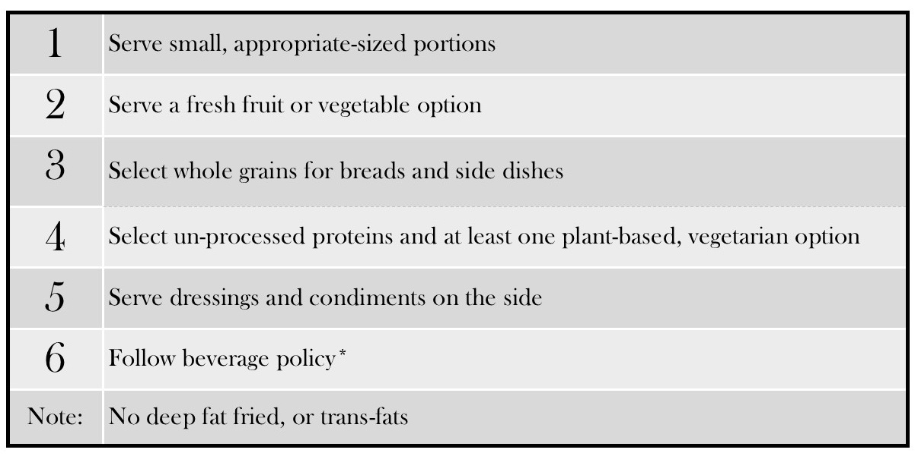
Healthy Food Policy
Top Priorities Include:
- Vegetables and/or fruit
- Water instead of sugary drinks
*Beverage policy: All beverages must comply with “no added sugar” policy. No alcoholic, caffeinated beverages, or bottled water are allowed (NCO will provide drinking water at the event, free of charge). Suggestions for allowable beverages are: 100% fruit juices or drinks containing 100% fruit juice or natural flavors; Milks with no added sugars; Herbal iced teas with no added sugars

NORTH COAST OPPORTUNITIES
413 N. STATE ST. UKIAH, CALIFORNIA 95482
Phone (707) 467-3200, Fax (707) 462-0191
FOOD VENDOR APPLICATION
NCO 50th Anniversary Celebration Picnic August 25th from 10 AM – 2 PM at Todd Grove Park

Applications must be turned in no later than 3pm on Thursday, May 17, 2018

NAME OF ORGANIZATION
/
CONTACT PERSON(S)
ADDRESS CITY STATE ZIP PHONE NUMBER(S) FAX NUMBER E-MAIL
FOOD VENDOR FEES:
In lieu of a $250 vendor booth fee for this event, NCO asks that vendors offer a majority of their food items
for $5 or less. NCO is committed to offering economical choices to our event-goers.

Please refer to the HEALTHY FOOD AND BEVERAGE POLICY on page 1
In the space below, please list the items to be sold, how they meet policy requirements, and price:
Items not listed CANNOT be sold without prior approval. Food and beverage items for sale can be updated prior to the event if needed
Item (food or beverage) | How it meets health policy | Price
WILL BE SERVING MEALS IN: ___Food Truck ___Food Trailer

___Tent (Booth/Tent) Size: ___ ft. frontage size X ___ ft. deep

For Office Use
APPROVED: Yes - No
No

Date Received __________________________ ____Insurance Certificate ___________________________

Damage Deposit_____________________________Payment Type________________________________
Food Permit ______________________________
Include with this application:
Attach a copy of current Food Permit from County Environmental Health Department and Insurance Certificate.
FOOD VENDOR AGREEMENT
VENDORS MUST AGREE TO THE FOLLOWING TERMS:
- Vendor shall provide full-service permitted food truck (or permitted food sales tent) for the sale of food and beverages at Todd Grove Park in Ukiah on August 25, 2018 event runs from 10 AM – 2 PM. Vendor’s services shall include, but not be limited to furnishing 2-3 lunch menu choices for sale to event participants. All foods for sale must adhere to the “Healthy Food Policy” in this agreement.
- In lieu of a $250 vendor sales fee for this event, NCO asks that vendors offer a majority of their food items for $5 or less. NCO is committed to offering economical choices to our event-goers.
- Vendors are responsible for compliance with all relevant city and state codes and licenses. Vendors must have a seasonal or short-term Mendocino County health food permit. Health inspectors will be on site and will ensure that food-dispensing guidelines are followed. Please provide copy of current Food Permit.
- Vendors must supply proof of insurance showing NCO 50th Anniversary Celebration Picnic as additional insured. Please provide a copy with this application.
- All cups, plates, bowls, knives, forks and spoons, napkins, straws, stirrers, packaging etc, must be made of paper, wood or other compostable and biodegradable materials. No plastics or Styrofoam.
- Vendors may only sell in the space designated by event organizers and may only sell items listed in and agreed to in this contract. Any changes to the sell items must be approved by the event organizers.
- Electrical service is available this event. You will need to bring an appropriate extension cord to access the power.
- Vendors must arrive between 8:00am and 8:45am at the event venue.
- No vehicles will be allowed to remain in the park after 9:30 a.m. except for the food truck, trailer, or tent.
- Vendors shall be completely ready to begin food and beverage sales at 10:00am and commence packing up no earlier than 2:00pm and no later than 3:00pm.
- There is a fully-refundable $200 damage deposit due if you are selected as an event vendor. At the event, vendors must keep their area presentable during the event and clean up their area completely before leaving at the end of the event. Special attention must be taken to prevent oil stains, spills or dumping. Failure to comply will result in the loss of the damage deposit. All cooking oils, cardboard boxes and other vending or cooking debris must be carried out for disposal or recycling.
- NCO assumes no responsibility for any financial loss, theft or injury.
- Vendors shall fully indemnify and hold harmless NCO and the City of Ukiah from any actions, suit, claims, payment, costs or damages which may be brought against them arising from participation in the NCO 50th Anniversary Celebration Picnic.
This document is a contract between the food vendor and North Coast Opportunities (NCO). Upon acceptance, this document will serve as a contract between NCO and the food vendor. All vendors must abide by this contract. Failure to comply with the terms listed above will result in cancellation of your participation in the NCO 50th Anniversary Celebration Picnic and forfeiture of your damage deposit.

Signature of Food Vendor, Date, California Tax ID # Signature of NCO Food Coordinator, Date

_____________________________________________ ____________________________________________

The term of this Agreement shall commence on upon signing (the “Effective Date”) and continue through August 25, 2018 at 5pm, unless earlier terminated due to lack of compliance with all provisions of this Agreement. All indemnification provisions contained in this Agreement shall survive beyond the expiration of this Agreement.

